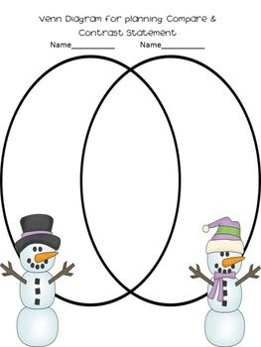
Compare and contrast the fiction and nonfiction piece about Wilson Bentley.

